## CHILDERN SAFETY TRACKING

MY APP'S NAME : CHILDREN SAFETY TRACKING

Link to the App - https://studio.code.org/projects/gamelab/eVHFAZkbIjYHLmPZJFKtJUEaOU2qc6F4-36q8TPlllY

INTRODUCTION:

Problem statement :

Lives of students leaving school by private vehicle or school vehicle or walking are subjected to risk no matter how short the interval is. Some careless drivers are leaving the kid in their residence and think only a few seconds would take to go inside home, but that is the crucial time where the child may lose safety.

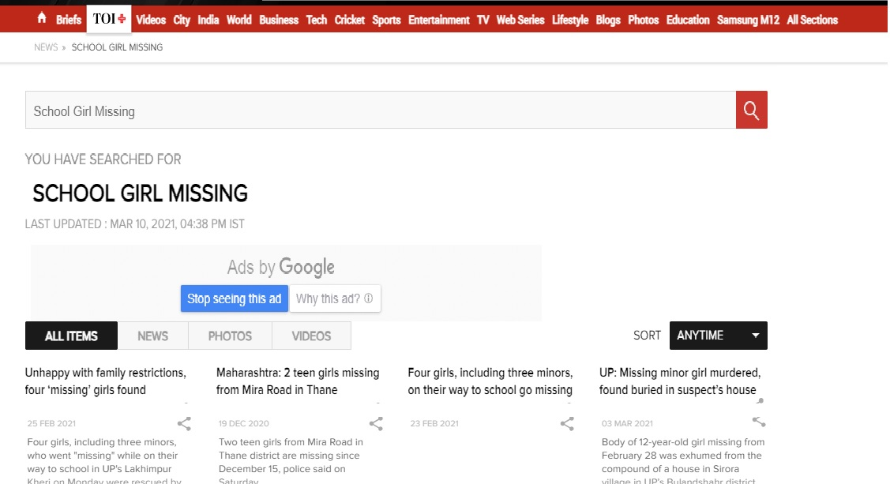

OVERVIEW :

My app is based on children's safety. Now a days there is no safety for children of all age categories especially girls. It's like a magic and wonder for kids to come home safely. Everyday almost 5000 kids are getting kidnapped and some are even killed by the evil souls. There is only fear to the core and all parents are fussed until their kids reach home. Children are touching the rims of risk in their daily life. It would be a simple solution.



SOLUTION :

According to my app, the parents will be given intimation that their child has come out of the school by a alarm alerting them and other alarm as soon as they reach home. So that parents can note at what time the child leaves and if he/she is coming safely on time. It is very useful for parents as well as children. Parents can work peacefully after hearing the alarm guessing that their child has reached home.

There will be two buttons one to ON and the other to OFF. The teachers and parents have to type a password and then app starts working. This app should be installed by both parents and children. The control is given to the teacher who has to click the ON button and the parents who have to select the OFF button. My app will fetch the API for GPS and database for the live time values. The app should be installed by the parents in their mobile and also by students in their digital watches as most of them wear it or by the school.

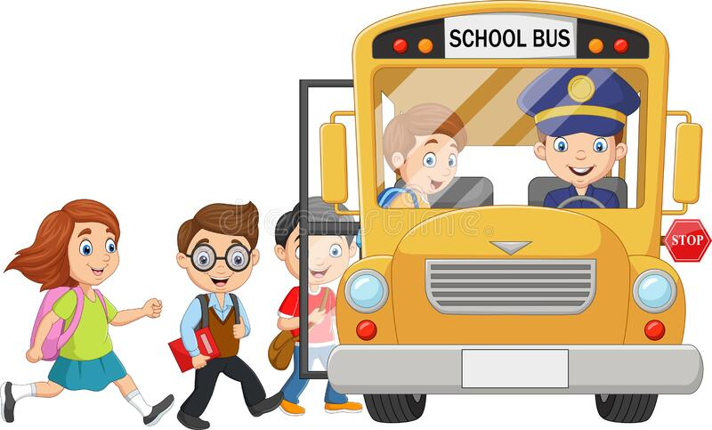 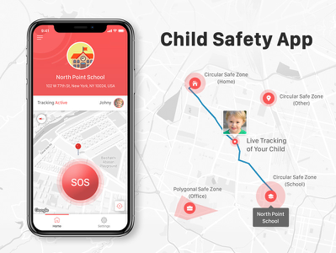

It is a very safety app which could have no ill effects. I think parents are looking forward for such apps. The main aim or goal is the protection of the children who are going to become the future ruling class. Moreover seeing the broken hearts of the parents who are struggling by missing their children I think this would be a good solution.

when they install this app :

1.Welcomes you

2.Asks the parents to give password. (Parents have to select the OFF button)

3.Asks the teachers to give password. (Teachers have to ON the button)

4.Alarms the parent’s mobile when the child leaves the school along with a message

5.Alarms the parent’s when the child reaches home along with a message

5.Shows the location where the child is struck it the alarm is not ringing ( if they have not left school or reached home)(for the upgraded version)

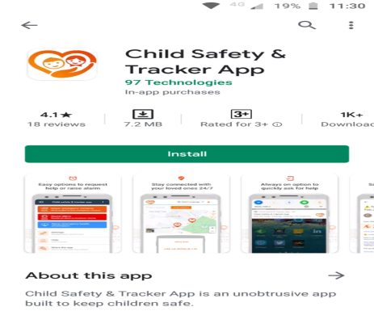

Being a student, I see many children not reaching home after school and kidnapped by someone. So for the safety of our future generation I mainly created this app.

I think it would be very useful in our today's society were all things are unruly.

 